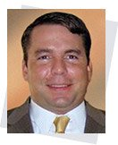
Dr. Jon D Risinger, Lead Coastal Engineer – MWH Global
Bio:
Dr. Risinger has over 10 years of experience and leadership in water/coastal resources planning, engineering, and project management. He specializes in non-rock alternatives and living biological solutions for shoreline protection in the Louisiana Coastal Zone and beyond. Jon is a former adjunct faculty in Civil Engineering at Fresno State, active member of ASCE Louisiana COPRI Institute, and a EWB volunteer.
Presentation Topic:
Sustainable Coastal Restoration using Bioengineered Oyster Reefs as ‘Living’ Shorelines
Shorelines are often stabilized with concrete structures and rock emplacements (riprap) to mitigate erosion. These structures often preclude biological processes and some require long-term maintenance. A more natural and sustainable bank stabilization technique called “living shorelines” uses plants, sand, and concrete substrates to provide shoreline protection and facilitate habitat diversity. Bioengineered oyster reefs are a form of living shoreline solutions that use concrete as a scaffolding for oyster growth. Living Shorelines use natural shoreline ecosystems to absorb wave energy without causing erosion.
Dr. Milton Saidu, Ph.D. – Louisiana State University
Bio:
Dr. Milton Saidu is a graduate from Louisiana State University, with expertise in biological filtration of water and applications of process control for automation of systems. Dr. Saidu’s current research focus involves optimizing design of closed water recirculation systems. This also includes promotion of renewable energy sources particularly solar and wind energy for environmental sustainability and systems energy efficiency.
Presentation Topic:
Use of alternative energy for water recirculation and sustainable fish production

Angela Cason, Integration Engineer & Samantha Snabes, Strategist – NASA
Bios:
Angela Cason has been a member of the EWB-USA South Houston Professional Chapter at the Johnson Space Center since 2008 where she also serves as the chapter’s secretary. Her work for the chapter has been on a rapid sand filtration system that she traveled to Aguilar, Mexico to implement and on the current fruit dehydration system for an orphanage in Rwanda. In 2011 she traveled to Rwanda to implement 3 solar fruit drying systems for the orphanage and traveled back in September 2012 for an assessment of the year-round fruit dehydration system planed for implementation in the summer of 2013. Angela’s Bachelor of Science is in Human Factors Engineering with a Masters of Aeronautical Science with a specialization in systems safety and technical management both from Embry-Riddle Aeronautical University. She currently works at the Johnson Space Center as the International Space Station Russian Segment Integration Manager.
As a challenge seeker and continuous learner, Samantha is passionate about human space exploration and social impact. Currently, she serves as the Social Entrepreneur In Residence for the NASA Open Innovation Program and the Treasurer for the Engineers Without Borders South Houston Professional Chapter. Her professional and extracurricular experiences include marketing, biotechnology, social innovation, tissue culture, small business start-up & acquisition, product engineering, emergency response, communications & strategy, microfinance, agriculture, and animal husbandry. Samantha holds a Bachelor of Science in Biology, Bachelor of Arts degrees in International Relations and Hispanic Studies, a MBA with concentrations in Supply Chain Management and International Business, and certifications as a Firefighter and an EMT-B.
Presentation Topic:
Fundraising and PR
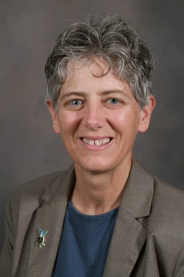
Marybeth Lima, P.E. – Louisiana State University
Bio:
Marybeth Lima is the Cliff & Nancy Spanier Alumni Professor in Biological & Agricultural Engineering at LSU, a registered professional engineer, a nationally certified playground safety inspector (CPSI), and the Director of the LSU Center for Community Engagement, Learning, and Leadership (CCELL). In 1998, Marybeth established the LSU Community Playground Project, a service-learning program which pairs elementary school and college students to design and build “dream playgrounds” at local public schools. These sustained efforts have led to the construction of more than 25 collaboratively designed playgrounds. She is author of the forthcoming book Building Playgrounds, Engaging Communities: Creating Safe and Happy Places for Children (LSU Press, 2013).
Presentation Description:
Successful projects completed through Engineers Without Borders USA require input and trust from all constituencies. I will be talking about partnership principles and employing them in ways that will result in successful collaborations. I will be sharing lessons learned from 15 years of experience of engineering in conjunction with the community.
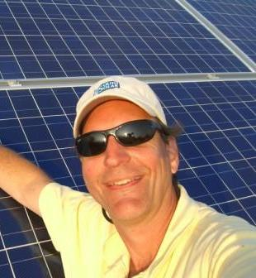
Jeff Shaw – Gulf South Solar
Bio:
Jeff Shaw is the President of Gulf South Solar; a Baton Rouge based regional solar integrator as well as the Executive Director of the Louisiana Solar Energy Society. He was recently recognized by the American Solar Energy Society for his contributions to solar in the state. An LSU engineering graduate, Jeff has over 30 years experience in control systems and solar engineering. He is the author of Louisiana’s net metering legislation as well as being instrumental in aiding the adoption of the current solar state tax credit and Solar Rights legislation. In addition to founding the Baton Rouge Community College solar installation class, Jeff has lived in a solar powered home since 1999 and enjoys teaching solar classes to engineers, architects, homeowners and installers.
Presentation Topic:
Low Tech Solar System Design

